Assignment 9
Name- vaishnavi shirke
MCA-2504097

Step 1: Login to Azure Portal
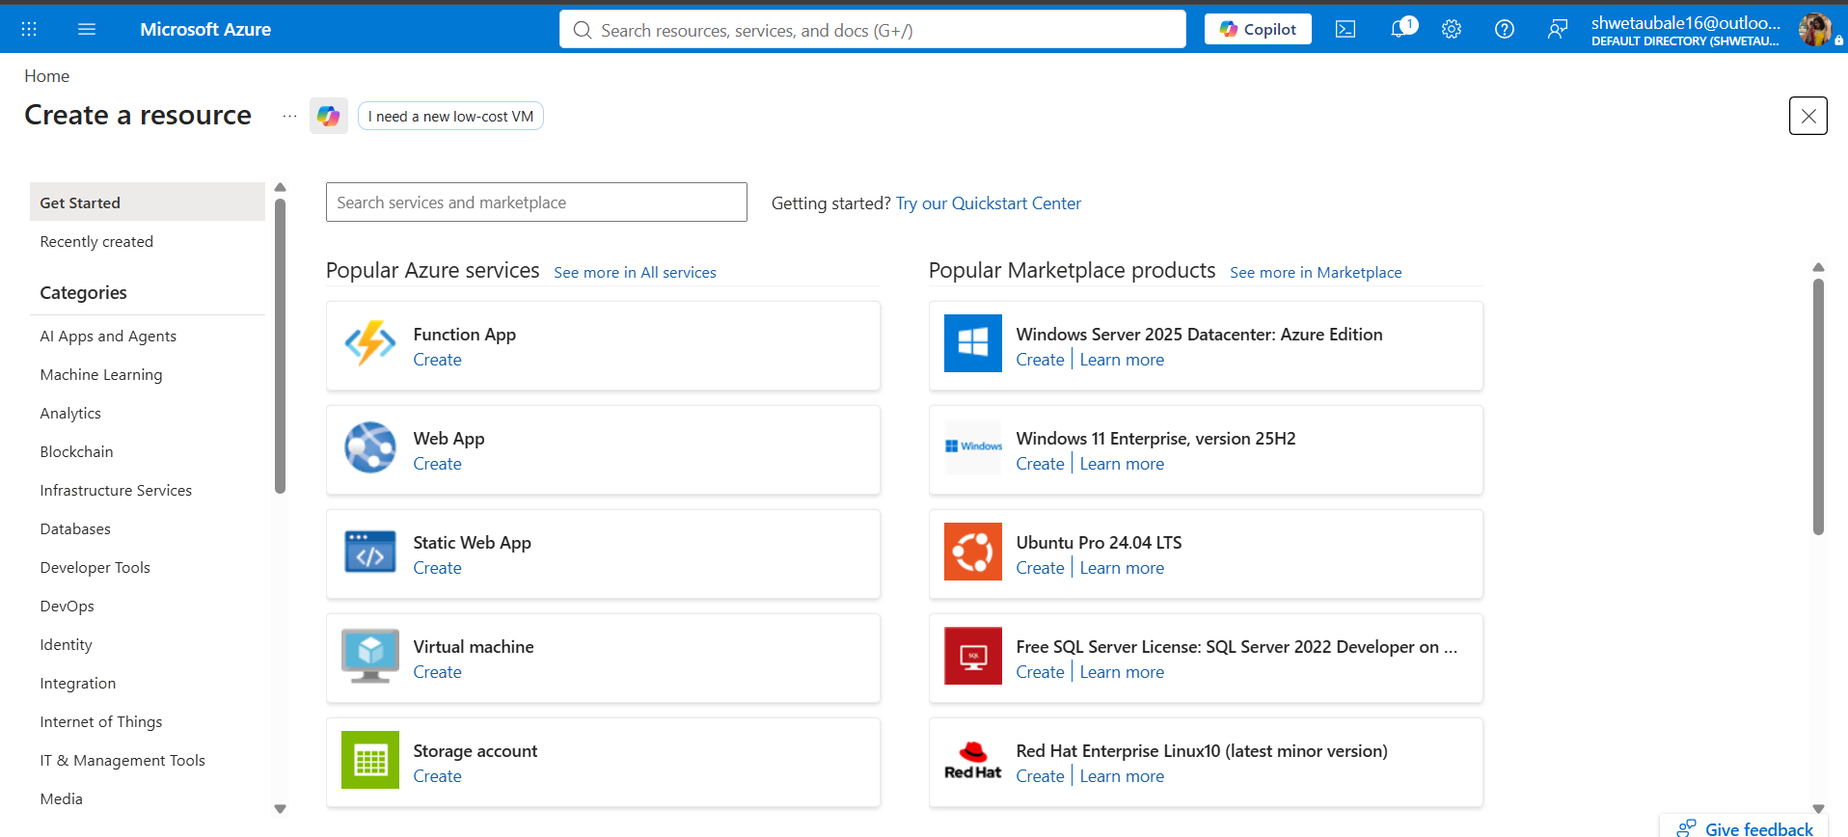
Step 2: Create a Resource Group
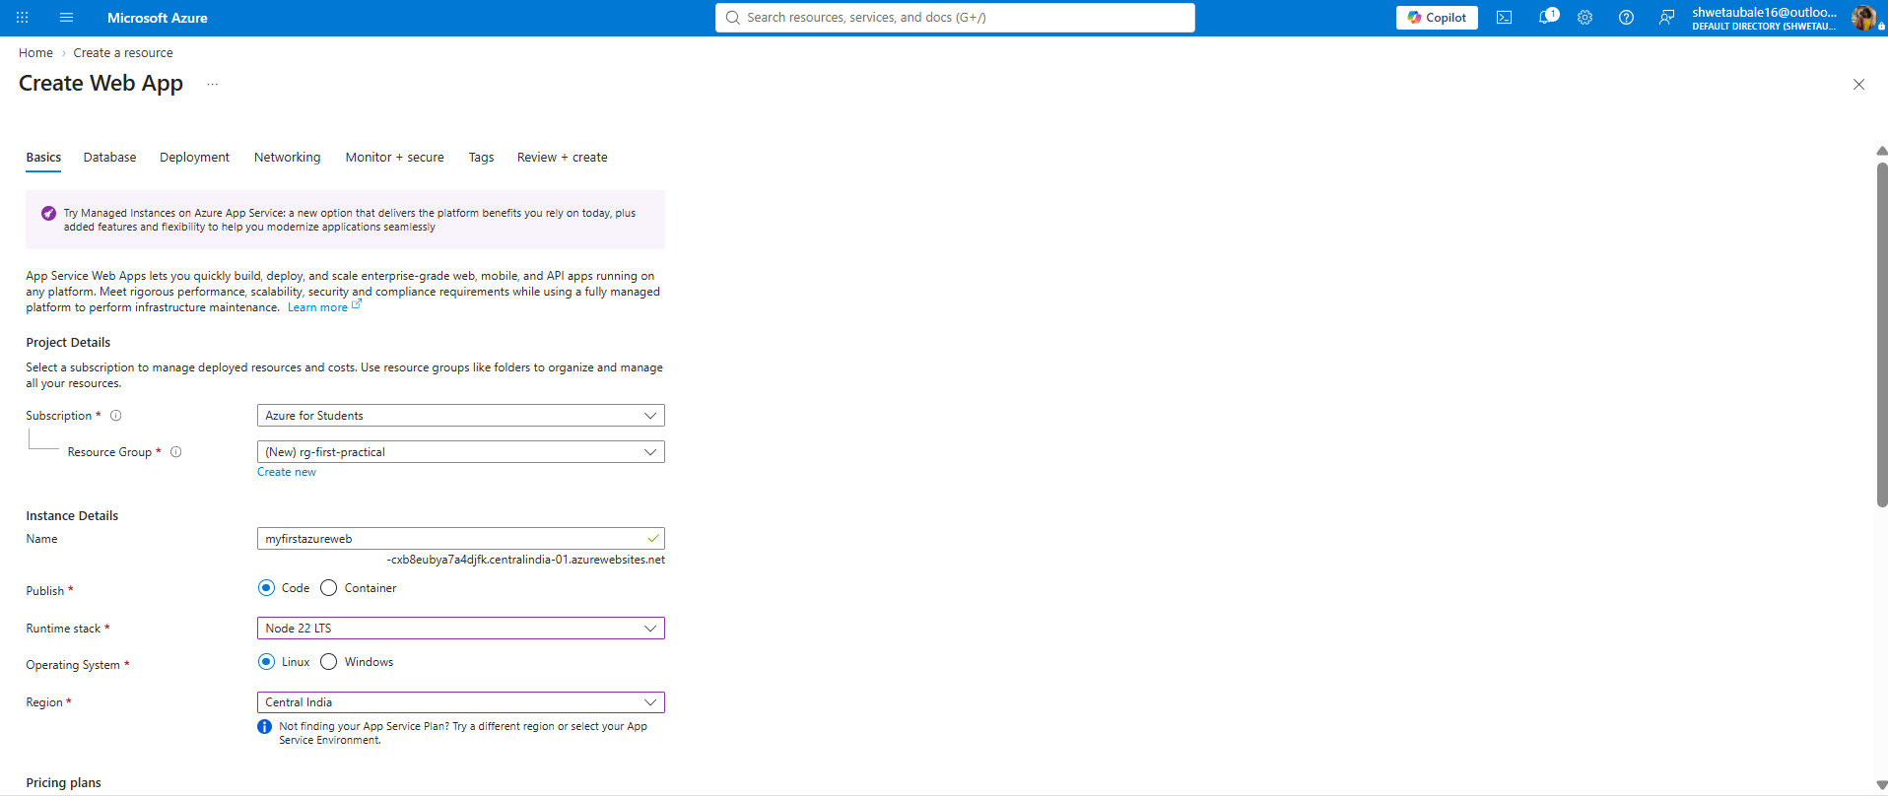
Fill in the Details:
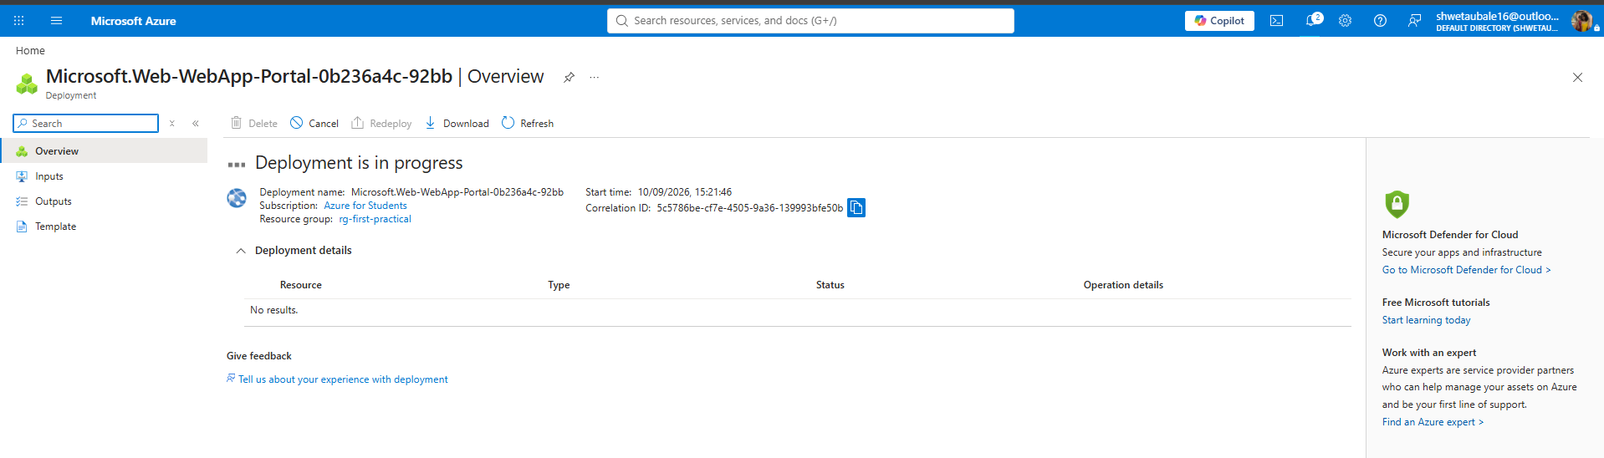
Step 3: Create a Web App (Website)
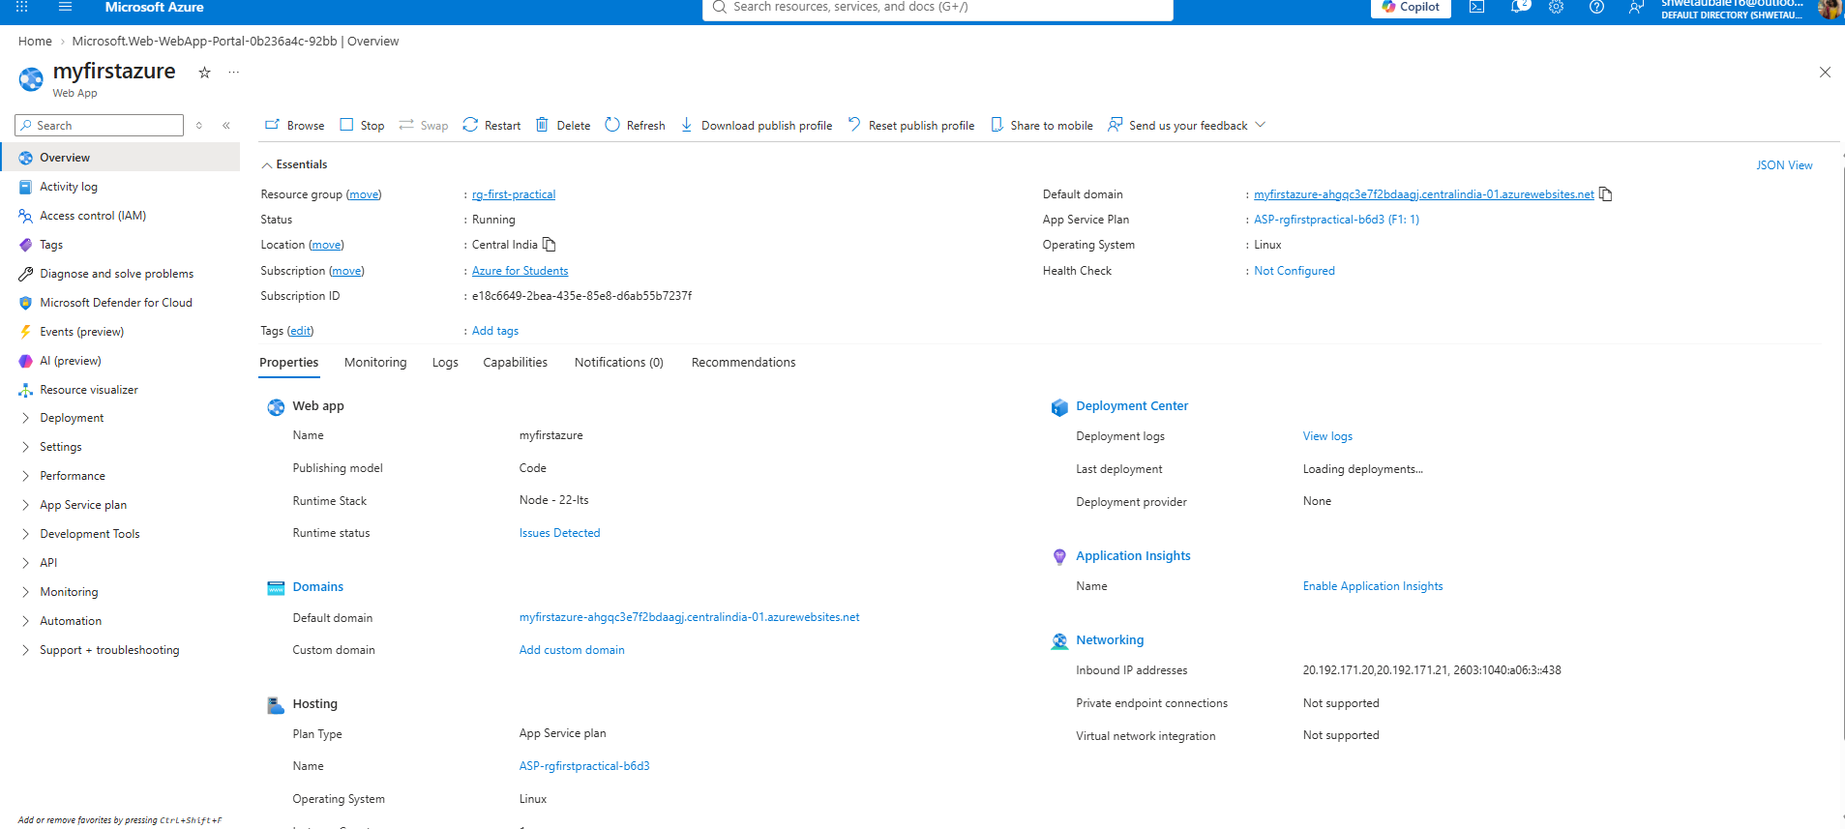
Step 4: View Your Live Website
URL of the Website: https://myfirstazure-ahgqc3e7f2bdaagj.centralindia-01.azurewebsites.net/
